**A Project Report On**

**Campaign Management System**

**(By SEMESTER-X of V Year M.Sc. (2019-20))**

**Bhavesh Koshti : 5110**

**Submitted To**

kslogo

K. S. School of Business Management

M.Sc. – Computer Application and Information Technology

**Acknowledgement**

In performing our project, we had to take the help and guideline of some respected persons, who deserve our greatest gratitude. The completion of this project gives us much pleasure. We would like to show our gratitude **Vandita Dhariyal (HR of Gateway Group of Companies), all teaching faculty of K.S. School of Business Management** for giving us a good guideline for assignment throughout numerous consultations. We would also like to expand our deepest gratitude to all those who have directly and indirectly guided us in writing this assignment.

*In addition, a thank you to project guide* ***Dr. Nandita Goswami****, who introduced us to the Methodology of work, and whose passion for the “underlying structures” had lasting effect.* Many people, especially our **classmates** and **team members** itself, have made valuable comment suggestions on this proposal which gave us an inspiration to improve our project. We thank all the people for their help directly and indirectly to complete our project

**INDEX**

1. INTRODUCTION

**1.1 ORGANIZATION PROFILE**

**1.2 SYSTEM DETAIL**

1.2.1 EXISTING SYSTEM

1.2.2 PROPOSED SYSTEM

**1.3 SCOPE OF SYSTEM**

**1.4 OBJECTIVES**

2. PROPOSED SYSTEM REQUIREMENT GATHERING

**2.1 STAKEHOLDER OF SYSTEM**

**2.2 REQUIREMENT GATHERING TECHNIQUE USED**

**2.3 CONSOLIDATED LIST OF REQUIREMENT**

**2.4 PROJECT DEFINITION**

3. SYSTEM MANAGEMENT AND PLANNING

**3.1 FEASIBILITY STUDY**

3.1.1. TECHNICAL

3.1.2. ECONOMIC

3.1.3. OPERATIONAL

**3.2 HARDWARE-SOFTWARE REQUIREMENT**

**3.3 SYSTEM PLANNING**

3.3.1 WORK BREAKDOWN STRUCTURE

3.3.2 GANTT CHART

**3.4 PROCESS MODEL**

4. SYSTEM ANALYSIS AND DESIGN

**4.1 UML(UNIFIED MODELING LANGUAGE)/DFD**

**4.2 SYSTEM FLOW DIAGRAM**

**4.3 DATA DICTIONARY**

**4.4 USER INTERFACE**

**4.5 SYSTEM NAVIGATION**

5. INPUT/OUTPUT DESIGN

6. TESTING

7. SUMMARY

**7.1 LIMITATIONS**

**7.2 FUTURE SCOPE**

BIBLIOGRAPHY

**CHAPTER: 1 INTRODUCTION**

This chapter gives an introduction about organization, existing system, proposed system and it also helps to know its scope and objectives.

**1.1 ORGANIZATION PROFILE**

|  |  |
| --- | --- |
| **Company Name** | The Gateway Group of Companies |
| **Company Address** | B/81, Corporate House, Judges Bunglow Road, Bodakdev, Ahmedabad, Gujarat 380054 |
| **Company Established** | 1997 |
| **Contact Person** | Vandita Dhariya |
| **Contact no** | 8527221753 |
| **Website** | <https://thegatewaycorp.com/> |
| **Services** | Solution Consulting  Digital Transformation  IT Services  Products & Platforms |

* The Gateway Corp, a privately held global enterprise, is headquartered in India and The Netherlands. The Gateway Corp is the principal holding company and promoter of all Gateway Group Companies, comprising 20 independent operating companies across 16 countries.
* Over the last 22 years of Technology excellence, the Group has etched an enviable record of 80% client retention, in some of the most complex, non-English speaking markets, where we ensure that technology remains at the forefront of our clients’ business to achieve strategic differential advantage over their competition.
* Vision 2023 is built on this foundation. The aggressive strategy for organic and inorganic growth entails – development of disruptive solutions, strategic initiatives & partnership and new markets penetration.

**1.2 SYSTEM DETAILS**

**1.2.1 EXISTING SYSTEM**

* The traditional approach to creating marketing campaigns no longer is effective.
* Internal data, existing CRM systems, outdated workflow,combined with outdated perceptions and behaviors has created costly and inefficient marketing campaigns

**1.2.2 PROPOSED SYSTEM**

* Salon At door-Step helps you make better business decisions using near real-time, cloud-based point of sale salon business tools that take every part of your business and salon culture to the next level.
* He always wishes if we had one for ourselves too.... Now here is the opportunity to get a complete professional salon service at your doorstep.
* Their motto is to provide all sorts of exclusive and exotic beauty and hair treatment at the door-step, so that every customer (Men and Women) can enjoy the services in their comfort zone and time.
* He provides people with reliable and soothing salon like experience at their home.
* Professional well versed in various beauty treatments will be made available at door-step for glamorous make over.
* He will provide beauty treatments such as Hair Spa, Threading, Facial, Bleach, DeTan, Waxing, Threading, Manicure and Pedicure with online booking.
* **Scheduling** is one of the main reasons why people are looking for doorstep salon. Scheduling allows.

**1.3 SCOPE OF SYSTEM**

* The scope of the CMS system is to manage huge campaigns and its huge customers. It helps the organization to manage campaigns by just adding it in the system then they just have to observe where the campaign is going to lose or to profit. The organization can check all its previous campaign and check which strategy was used and how much profit was gained by that campaign

**1.4 OBJECTIVES**

* To develop a sustainable start-up business, contributing to increased employment of community residents.
* Keeping current client happy.
* We believe in total commitment to the team. The team objective is a guide for us to follow in our services to our clients, support of each other and team growth.
* We believe our system should be utilized in all activities to provide maximum efficiency and effectiveness for clients.
* We commit to managing out time and setting specific goals within that time.

**CH-2 PROPOSED SYSTEM AND REQUIREMENT GATHERING**

This chapter gives overview about system’s stakeholder, technique which used to gather requirement, list of consolidated requirement and project definition.

**2.1 STAKEHOLDER OF PROJECT**

* In all the system some person who directly or indirectly benefited from the system that are known as stakeholders.
* A person, group or organization that has interest or concern in an organization.
* Stakeholders can affect or be affected by the organization's actions, objectives and policies. Some examples of key stakeholders are creditors, directors, employees, government (and its agencies), owners (shareholders), suppliers, unions, and the community from which the business draws its resources.
* Not all stakeholders are equal. A company's customers are entitled to fair trading practices but they are not entitled to the same consideration as the company's employees.
* An example of a negative impact on stakeholders is when a company needs to cut costs and plans a round of layoffs.

In our system there are mainly three persons who are stakeholder; those are Admin, Artist and Customer.

* **ADMIN**

Admin is the person who manages the whole system.

* For admin, there is no need of physical organization.
* Admin will manage whole system online. It includes management of artists, customers, orders and schedule.
* This system provides efficiency for admin because nowadays for admin it was very difficult to manage this all manually.
* **ARTIST**
* Artist can work from home.
* For artist no need to go at any salon and work for particular hours.
* Artist can choose their own suitable time.
* Artist got the request of service and by availability of him he/she can provide their service.
* **CUSTOMER**

User who use the system and get benefit from the system and they perform all the possible things which are provided into the system.

* Customer will get salon at door-step.
* Their motto is to provide all sorts of exclusive and exotic beauty and hair treatment at the door-step, so that every customer (Men and Women) can enjoy the services in their comfort zone and time.
* They provide you with reliable and soothing salon like experience at your home. Professional well versed in various beauty treatments will be made available at door-step for glamorous make over.
* They will provide beauty treatments such as Hair Services, Waxing service, DeTan, Bleach, Manicure, Pedicure, Threading, Eyebrows, Facial with online booking.

**2.2 REQUIREMENT GATHERING TECHNIQUE USED**

There are many techniques available for gathering the requirements completely and correctly from clients and stakeholders. Here are some requirement gathering techniques:

#1: Interview Technique

#2: Facilitated sessions

#3: Questionnaires

#4: Prototyping

#5: Observation

#6: Brainstorming

* We have used “Interview Techniques” and “Observation” for requirement gathering as it is useful to obtain detailed information.
* **Interview Questions**

**To Admin**:

1. *How long have you been a owner at your physical salon?*
2. *What problem are you facing with current manual system?*
3. *Are you using any system currently?*
4. *What are you expecting from the system?*
5. *What is feasible to you? Door-step service or physical salon? Reason?*

**To Customer**:

1. *How frequently do you visit a salon?*
2. *What makes you choose a specific salon?*
3. *Where have you seen or heard of salon advertising in last 6 months?*
4. *What social network applications do you actively using on your mobile?*
5. *How long have you been a customer at your current hair or beauty salon?*
6. *How did you find your current salon?*
7. *What factors influenced your choice of current salon?*
8. *What problem are you facing with current manual system?*
9. *What is feasible to you? Door-step service or you want to go for salon?*
10. *What are you expecting from the system?*

* **Observation**

We observed that there are more number of customers grouped at the same time and salon get stuck by customers so that more number of customers have to wait or they leave the salon. There are also job persons who can’t wait in a queue and have busy schedule so they need such type of facilities at their residence. Because of hurry, sometimes customers not satisfied with the services. That’s why number of customers are reduced.

**2.3CONSOLIDATED LIST OF REQUIREMENTS**

Consolidated requirement means requirement combined/integrated into a single more effective or coherent whole.

* So the owner planned to make a system which will provide salon at doorstep. Their motto is to provide all sorts of exclusive and exotic beauty and hair treatment at the door-step, so that every customer (Men and Women) can enjoy the services in their comfort zone and time. They provide you with reliable and soothing salon like experience at your home. Professional well versed in various beauty treatments will be made available at door-step for glamorous make over. They will provide beauty treatments such as Hair Services, Manicure, Pedicure, Facial, Bleach, Waxing and Threading with online booking.

**2.4 PROJECT DEFINITION**

* So campaign management systems are all about managing campaigns where marketing or management teams from specific organizations can add and manage campaigns .
* And our system will send that specific campaign to customers via mail and then track customer responses and help the organization to decide whether the campaign was successful or not and represent it in chart format for the marketing team and will generate reports for the management team .
* And as per admin perspective admin can add customers from spreadsheet to database which can be used to send campaigns and also he can modify campaigns as needed and admin only will be adding organizations in the system as well as users .
* The organization teams also can add customers as per required needs via spreadsheet to database and can also select which customer to send campaign to and to which to not .
* So mainly the campaign management system is a bridge between organization and their customers .

**CH-3 SYSTEM MANAGEMENT AND PLANNING**

This chapter includes feasibility study of project. It checks whether the system is feasible or not. It defines hardware and software requirement for development of the system. It shows system planning with work breakdown structure and gantt chart. It also includes process model.

**3.1 FEASIBILITY STUDY**

**3.1.1 Operational Feasibility**

* It tells whether the system will work successfully or not. The answer is: There is full support of the owner and the user is fully involved in the planning. System will be able to perform a series of steps to solve the business related problems and to satisfy user requirements. So the system is operationally feasible.

**3.1.2 Economic Feasibility**

* As there is no paperwork required so it reduces the cost of working it manually.
* All people are aware of new technology so there is no problem to run the system and no special skills are required.
* Hardware/Software requirement client and server both the side is minimum, so there is minimum financial investment needed to use and make this system.
* Only one time development is required for this kind of system and if we want to expand it in future no more extra investment is needed.
* This system is economically feasible. It doesn’t require any additional hardware. Since the interface for this system is developed using the existing resources and technologies available.

**3.1.3 Technical Feasibility**

* What we have planned to implement is technically feasible. Do we have sufficient knowledge or technology to make it a reality? And the answer is yes we are having knowledge of technologies which are required for making this system working, we can easily design frontend using html, css and bootstrap and for backend we can use .net, mvc, c# and sql for database.

**3.2 HARDWARE-SOFTWARE REQUIREMENT**

**Software :**

Visual Studio 2017 or above version,

Sql Server 2017 or above version,  
 Visual Studio Code,

Browser: Chrome or Firefox (Any one of them)

**Hardware:**

OS:Windows 8 or above

Ram:8GB or above or more

HDD:500GB or more

**3.3 SYSTEM PLANNING**

**3.3.1 Work Breakdown Structure**

* A work breakdown structure (WBS) is a key project deliverable that organizes the team's work into manageable sections. The Project Management Body of Knowledge defines the work breakdown structure as a "**deliverable oriented hierarchical decomposition of the work to be executed by the project team**."
* The work breakdown structure visually defines the scope into manageable chunks that a project team can understand, as each level of the work breakdown structure provides further definition and detail.



**3.3.2Gantt Chart**

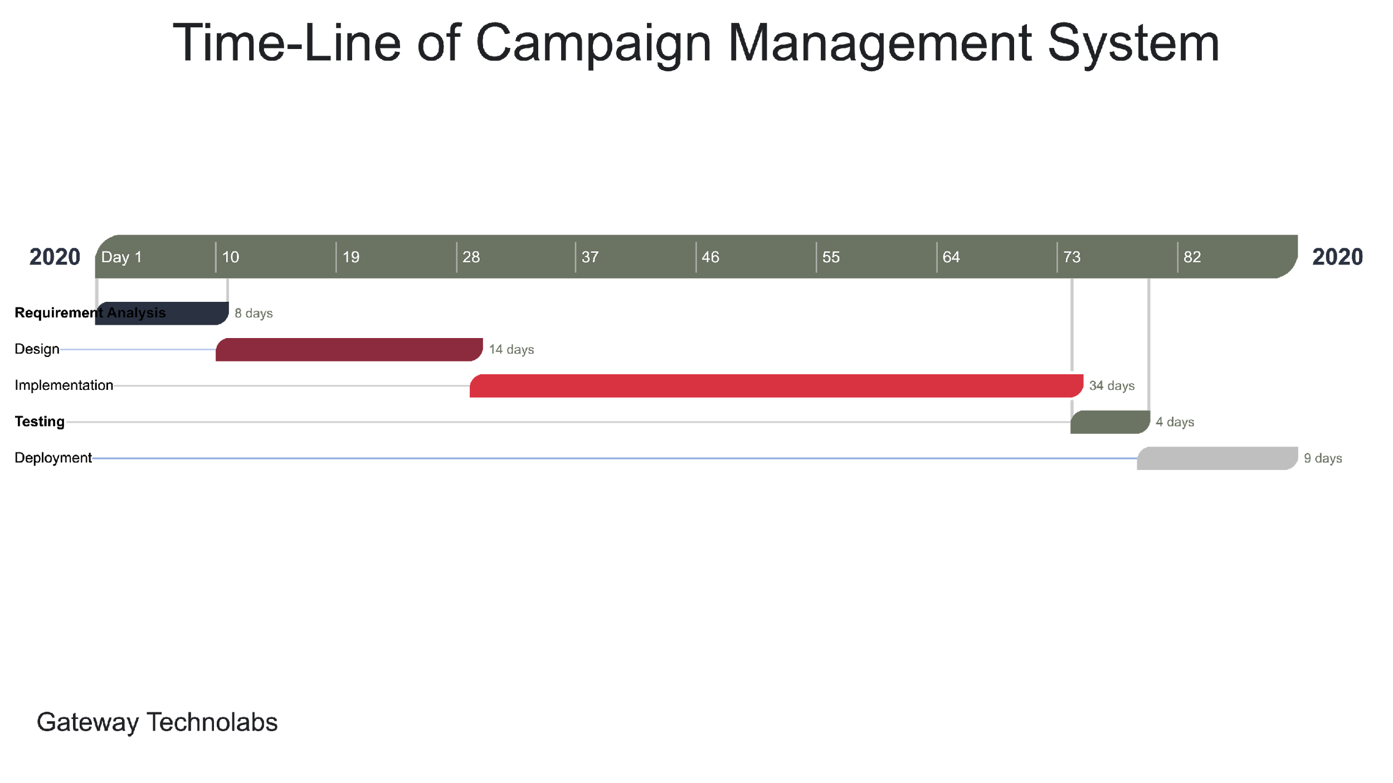

**3.4 PROCESS MODEL**

* There are many process models are available for development of any system or a software, but we are going to develop our system using **Agile Model**

**Agile Model**

Agile SDLC model is a combination of iterative and incremental process models with focus on process adaptability and customer satisfaction by rapid delivery of working software product. Agile Methods break the product into small incremental builds. These builds are provided in iterations. Each iteration typically lasts from about one to three weeks. Every iteration involves cross functional teams working simultaneously on various areas like planning, requirements analysis, design, coding, unit testing, and acceptance testing. At the end of the iteration a working product is displayed to the customer and important stakeholders.

**CH-4 SYSTEM ANALYSIS AND DESIGN**

This chapter shows the overall structure of the system. It contains use-case diagrams, activity diagrams, class diagrams, system flow diagrams, data dictionaries, user interface and system navigation.

* 1. **UML DIAGRAMS**

UML is a standardized modeling language enabling developers to specify, visualize, construct and document artifacts of a software system. It includes use case, activity, sequence and class diagram.

* **Use case Diagram**
* To model a system, the most important aspect is to capture the dynamic behaviour. Dynamic behaviour means the behaviour of the system when it is running / operating.
* Only static behavior is not sufficient to model a system rather dynamic behavior is more important than static behavior. In UML, there are five diagrams available to model the dynamic nature and use case diagram is one of them.
* Now as we have to discuss that the use case diagram is dynamic in nature, there should be some internal or external factors for making the interaction.
* These internal and external agents are known as actors. A use case diagram consists of actors, use cases and their relationships. The diagram is used to model the system/subsystem of an application. A single use case diagram captures a particular functionality of a system.
* Hence to model the entire system, a number of use case diagrams are used.
* In brief, the purposes of use case diagrams can be said to be as follows :
* Used to gather the requirements of a system.
* Used to get an outside view of a system.

Shows the interaction among the requirements is actors.

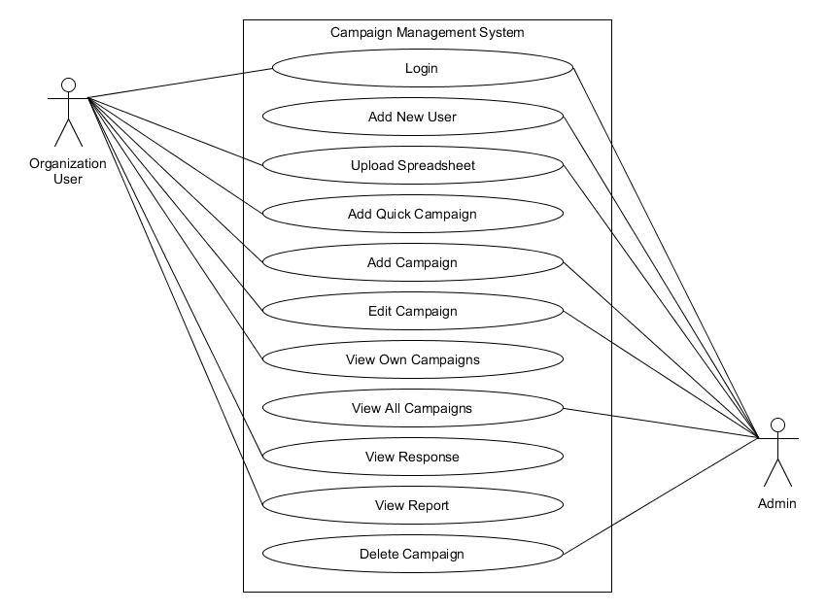

* **Activity Diagram**
* Activitydiagrams are graphical representations of workflows of stepwise activities and actions with support for choice, iteration and concurrency. In the Unified Modelling Language, activitydiagrams are intended to model both computational and organizational processes
* Activity diagram is another important diagram in UML to describe the dynamic aspects of the system.
* Activity diagram is basically a flowchart to represent the flow from one activity to another activity. The activity can be described as an operation of the system.
* The control flow is drawn from one operation to another. This flow can be sequential, branched, or concurrent. Activity diagrams deal with all type of flow control by using different elements such as fork, join, etc.
* The purpose of an activity diagram can be described as −
* Draw the activity flow of a system.
* Describe the sequence from one activity to another.
* Describe the parallel, branched and concurrent flow of the system.
* **Activity diagram**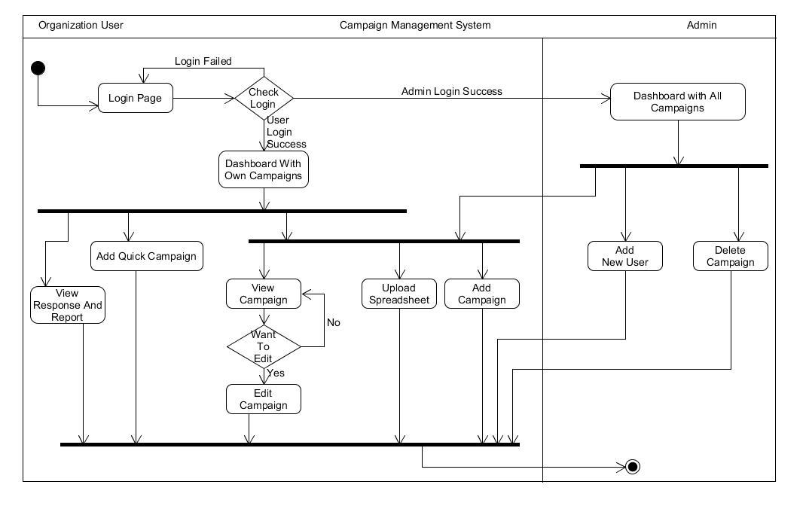
* **Class Diagram**
* Class diagram is a static diagram. It represents the static view of an application. Class diagram is not only used for visualizing, describing, and documenting different aspects of a system but also for constructing executable code of the software application.
* Class diagram describes the attributes and operations of a class and also the constraints imposed on the system. The class diagrams are widely used in the modeling of object oriented systems because they are the only UML diagrams, which can be mapped directly with object-oriented languages.
* Class diagram shows a collection of classes, interfaces, associations, collaborations, and constraints. It is also known as a structural diagram.
* The purpose of the class diagram can be summarized as −
* Analysis and design of the static view of an application.
* Describe responsibilities of a system.
* Base for component and deployment diagrams.
* Forward and reverse engineering.

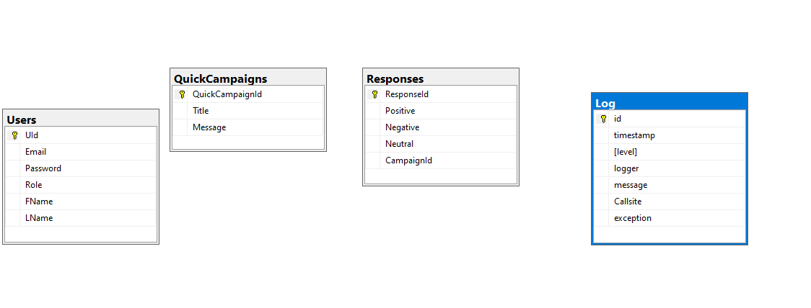

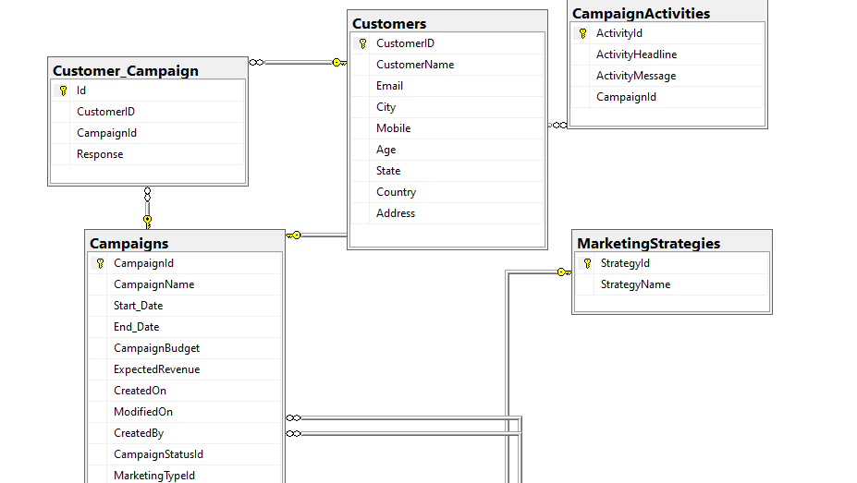

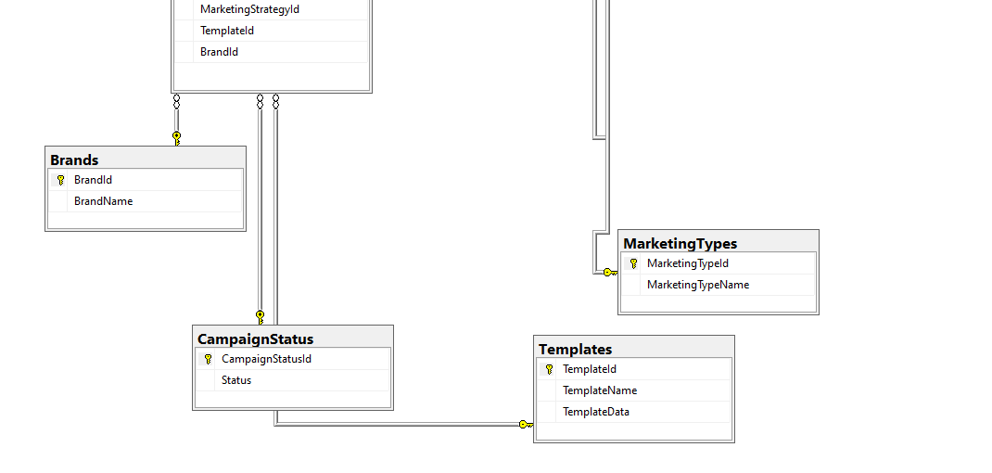

* **Sequence Diagram**

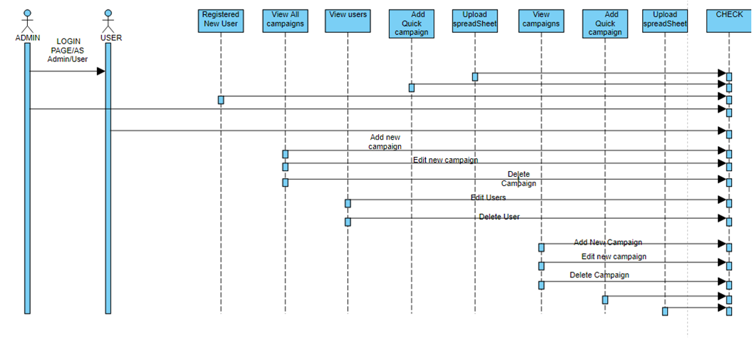

* 1. **SYSTEM FLOW DIAGRAM**

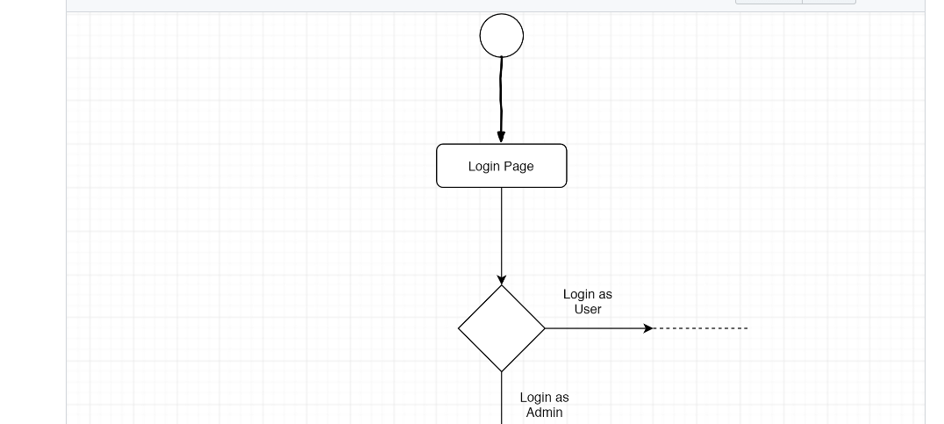

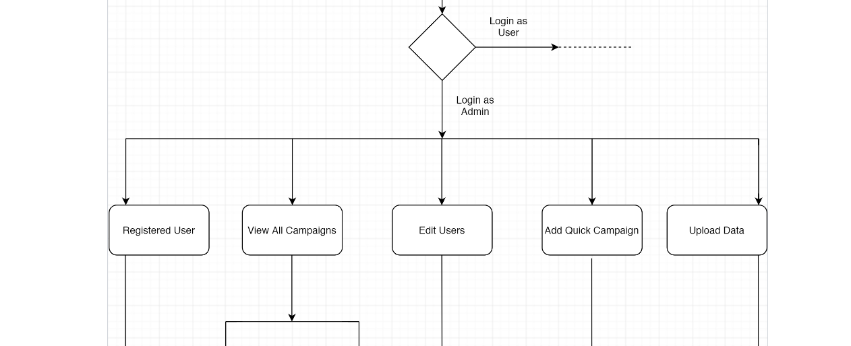

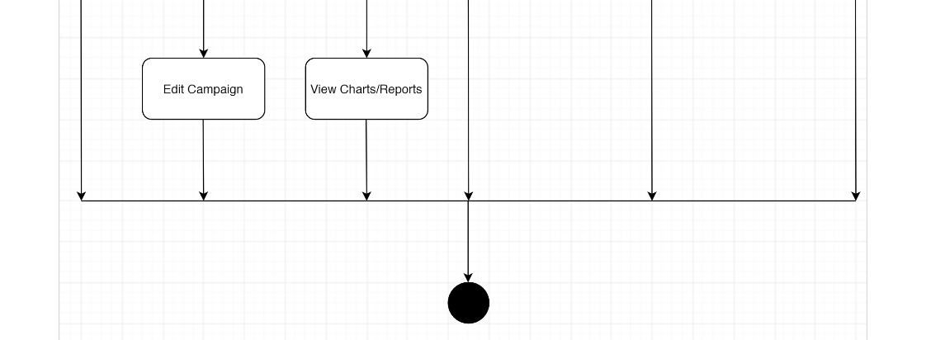

* 1. **DATA DICTIONARY**

1. **Campaign**

|  |  |  |
| --- | --- | --- |
| **Sr No** | **Column Name** | **Datatype** |
| 1 | CampaignId | Int |
| 2 | CampaignName | Varchar |
| 3 | CampaignOwner | Varchar |
| 4 | Start_Date | Datetime |
| 5 | End_Date | Datetime |
| 6 | CampaignBudget | Decimal |
| 7 | ExpectedRevenue | Decimal |
| 8 | CreatedOn | Datetime |
| 9 | ModifiedOn | Datetime |
| 10 | CreatedBy | Int |
| 11 | CampaignStatusId | Int |
| 12 | MarketingId | Int |
| 13 | MarketingStrategyId | Int |

Fig 5.5.1 Campaign Table

1. **CampaignStatus**

|  |  |  |
| --- | --- | --- |
| **Sr No** | **Column Name** | **Datatype** |
| 1 | CampaignStatusId | Int |
| 2 | Status | Varchar |

Fig 5.5.2 Campaign Status Table

1. **Customers**.

|  |  |  |
| --- | --- | --- |
| **Sr No** | **Column Name** | **Datatype** |
| 1 | CustomerId | Int |
| 2 | CustomerName | Varchar |
| 3 | Email | Varchar |

Fig 5.5.3 Customers Table

1. **MarketingStrategy**

|  |  |  |
| --- | --- | --- |
| **Sr No** | **Column Name** | **Datatype** |
| 1 | MarketingStrategyId | Int |
| 2 | StrategyName | Varchar |

Fig 5.5.4 Marketing Strategy Table

1. **MarketingTypes**

|  |  |  |
| --- | --- | --- |
| **Sr No** | **Column Name** | **Datatype** |
| 1 | MarketingTypeId | Int |
| 2 | MarketingTypeName | Varchar |

Fig 5.5.5 Marketing Types Table

1. **User**

|  |  |  |
| --- | --- | --- |
| **Sr No** | **Column Name** | **Datatype** |
| 1 | UId | Int |
| 2 | Email | Varchar |
| 3 | Password | Varchar |
| 4 | Role | Varchar |
| 5 | FirstName | Varchar |
| 6 | LastName | Varchar |
| 7 | OrganizationId | Int |

Fig 5.5.6 User Table

1. **Organizations**

|  |  |  |
| --- | --- | --- |
| **Sr No** | **Column Name** | **Datatype** |
| 1 | OrganizationId | Int |
| 2 | OrganizationName | Varchar |

Fig 5.5.7 Organization Table

1. **CustomerCampaign**

|  |  |  |
| --- | --- | --- |
| **Sr No** | **Column Name** | **Datatype** |
| 1 | CustomerCampaignId | Int |
| 2 | CampaignId | Int |
| 3 | CustomerId | Int |

Fig 5.5.8 Customer Campaign Table

1. **Responses**

|  |  |  |
| --- | --- | --- |
| **Sr No** | **Column Name** | **Datatype** |
| 1 | ResponseId | Int |
| 2 | CampaignId | Int |
| 3 | Positive | Int |
| 4 | Negative | Int |
| 5 | Neutral | Int |

* 1. **USER INTERFACE**

**Login:-**

## loginpage

**Registration:-**

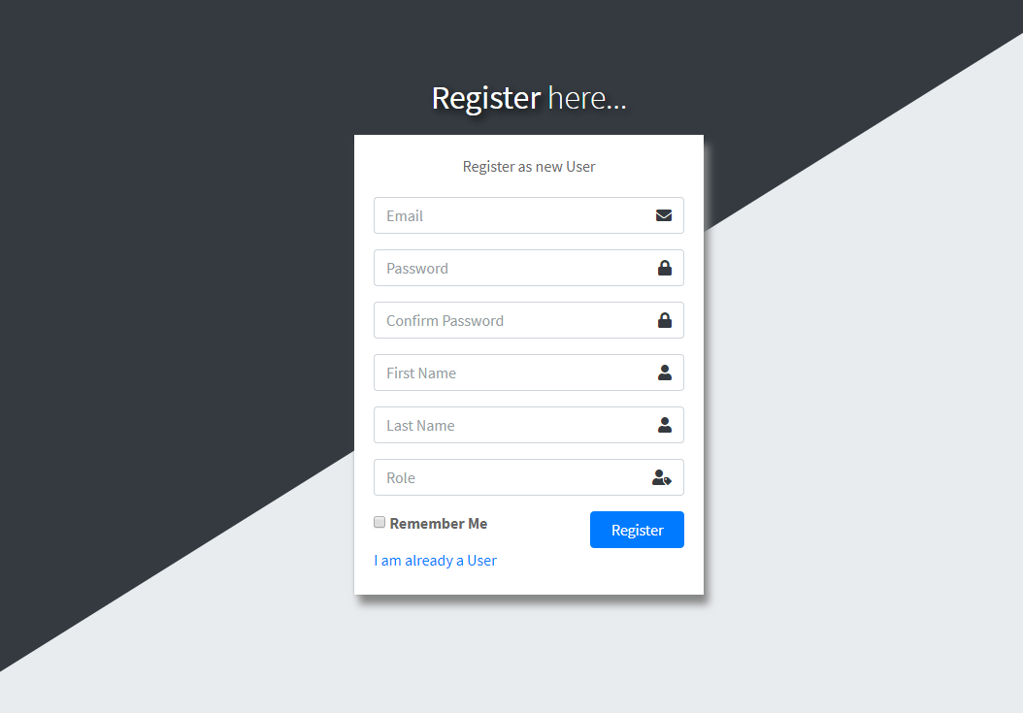

**Forget Password:-**

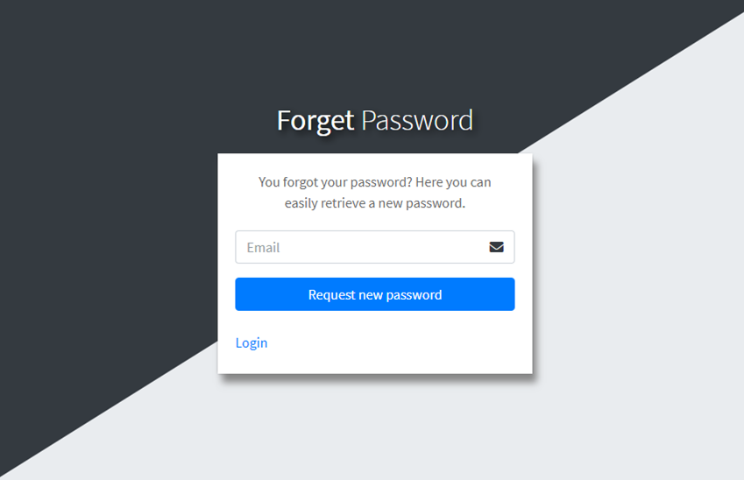

**Index:-**

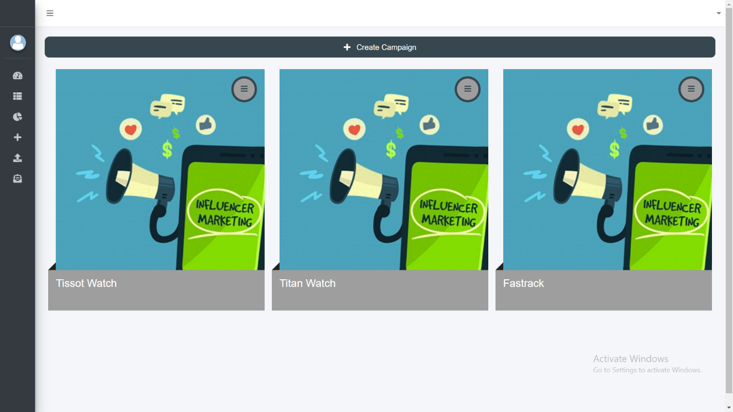

* **Add Campaign**

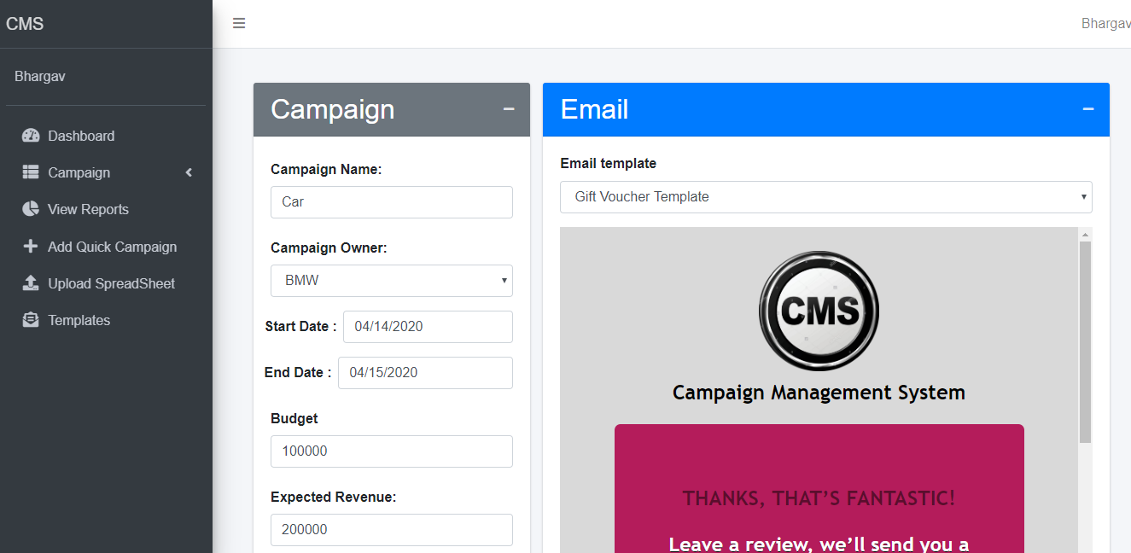

* **Edit Campaign**

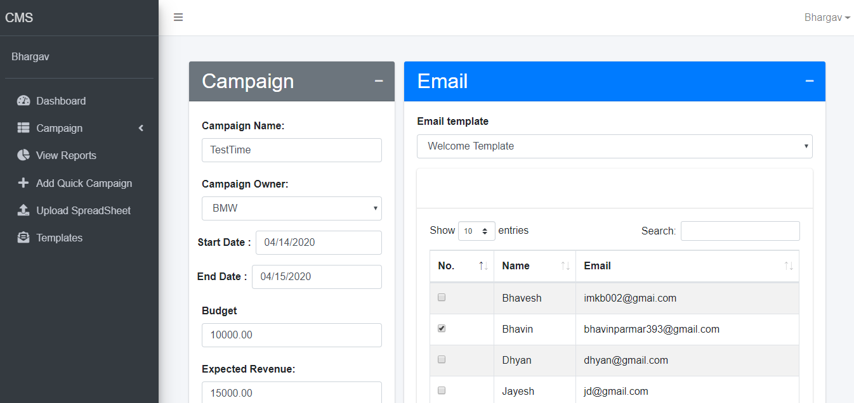

**Upload File**

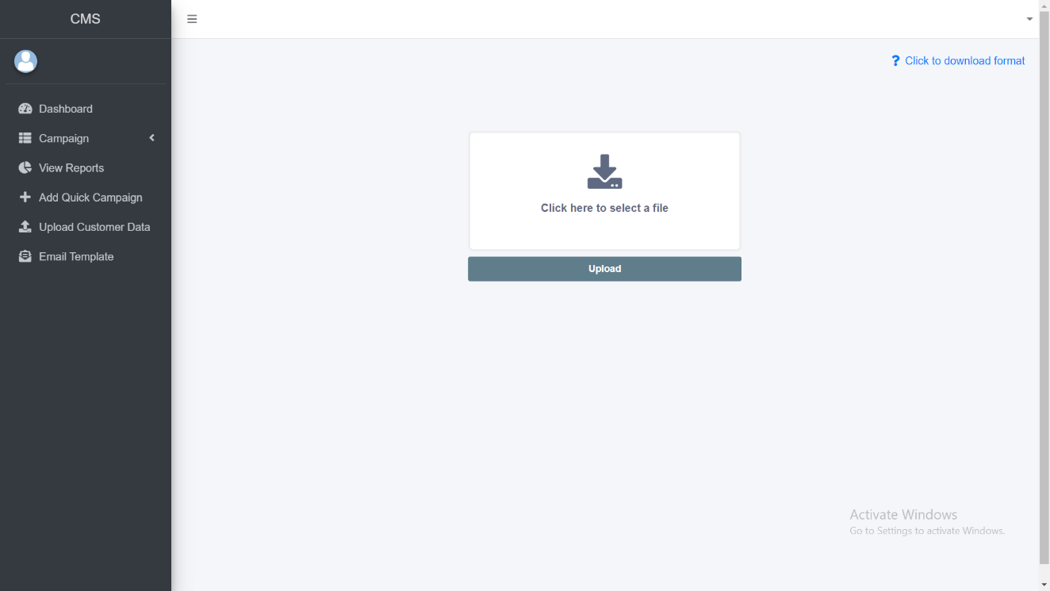

Email Tempate

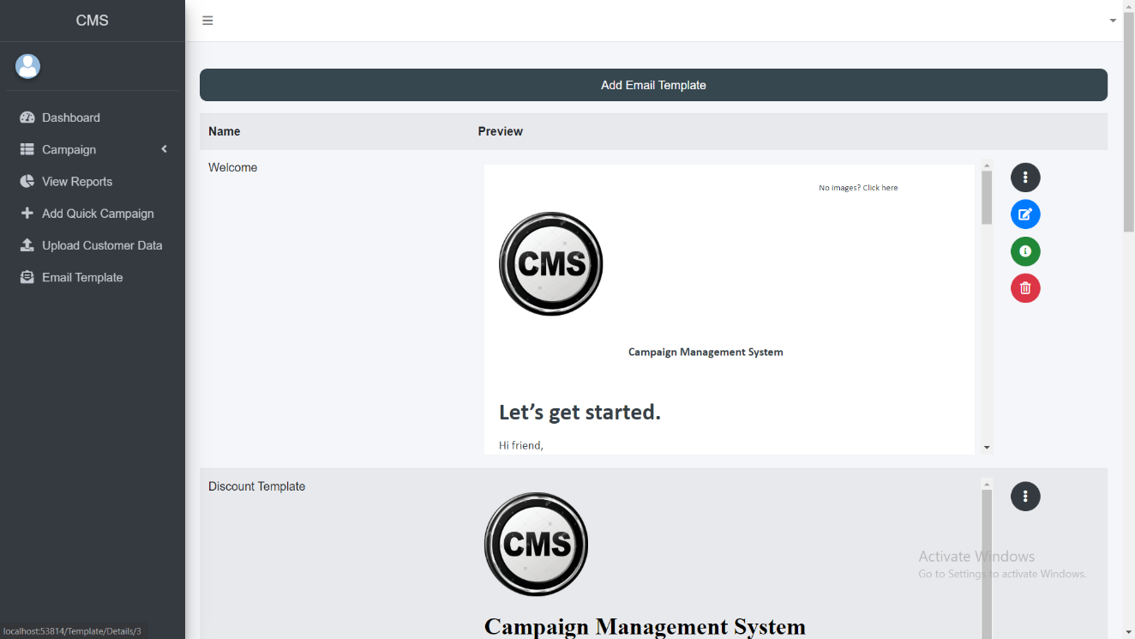

* **Create Email Template**

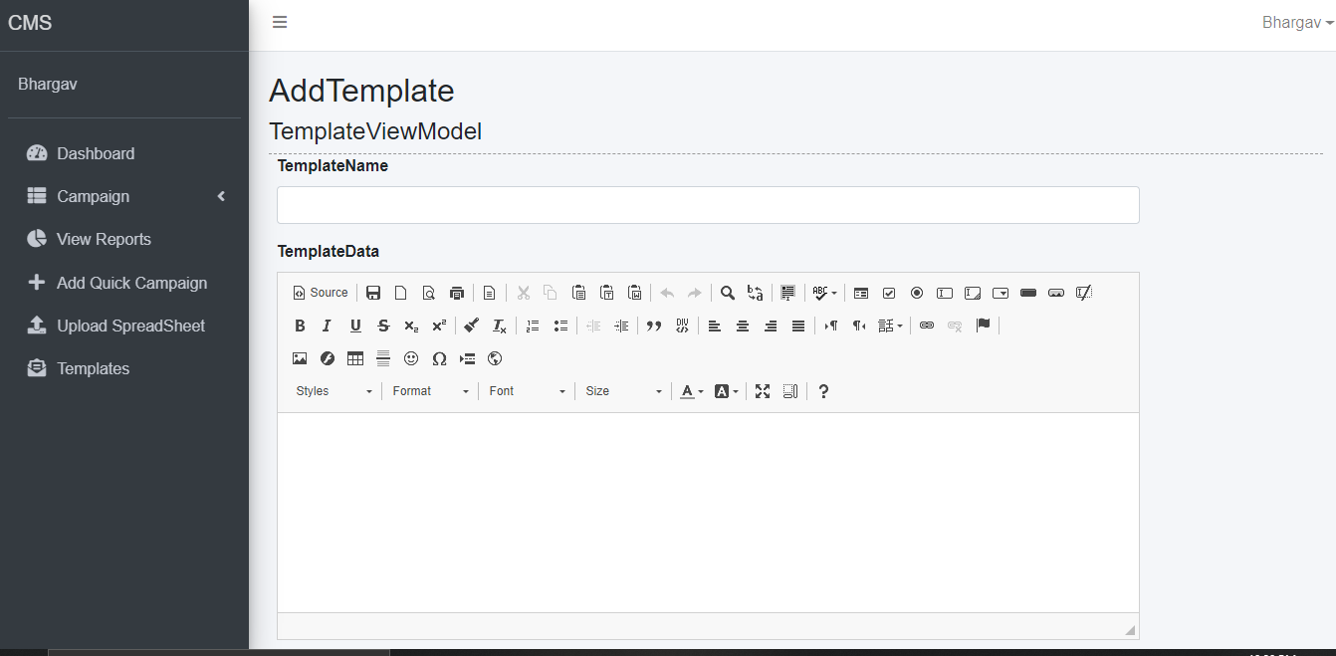

**Quick Campaig**

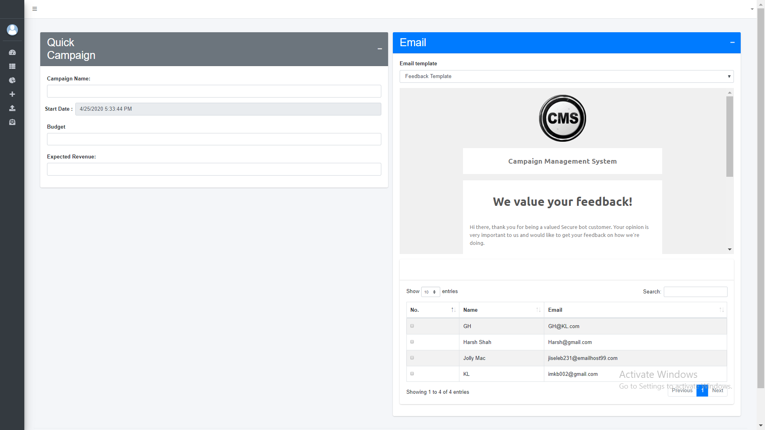

* **Error Page**

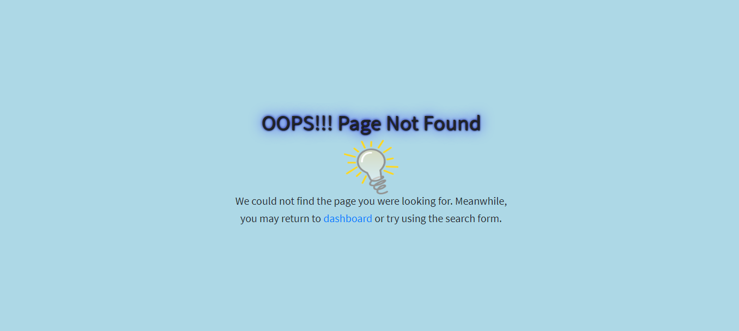

* 1. **SYSTEM NAVIGATION**

**NAVIGATION FOR ADMIN**

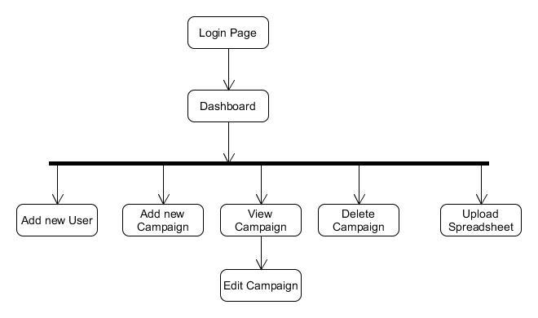

**NAVIGATION FOR USER**

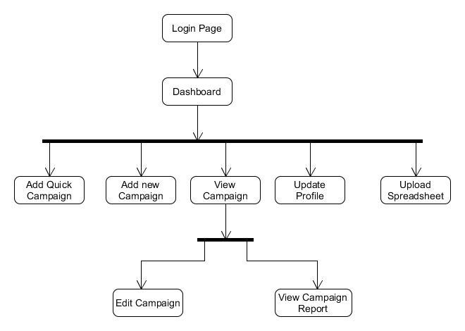

**CH-5 INPUT / OUTPUT DESIGN**

This chapter shows data insertion and output generated by it.

**Input-Add Area**

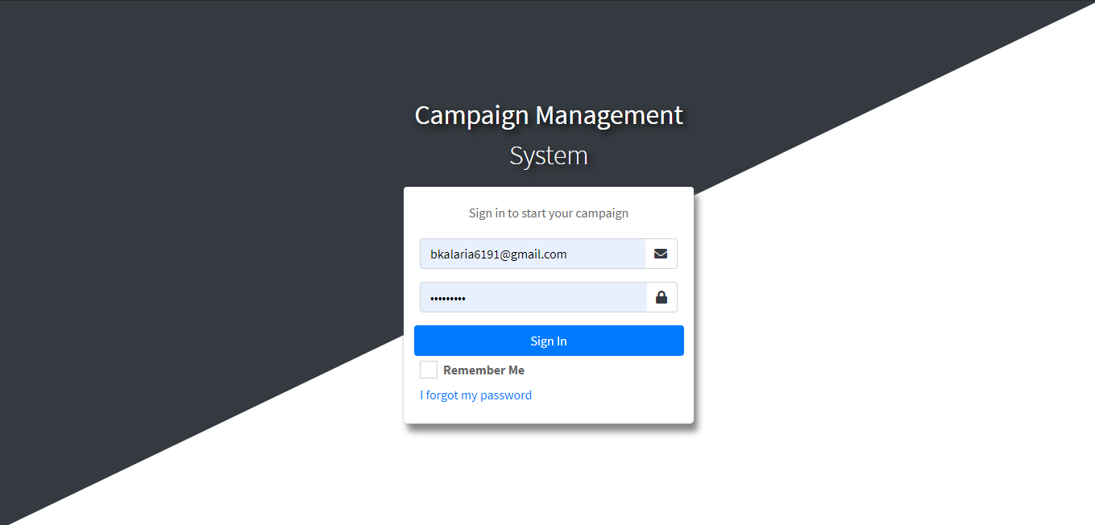

**Output- Manage Area**

**Input-Add City**

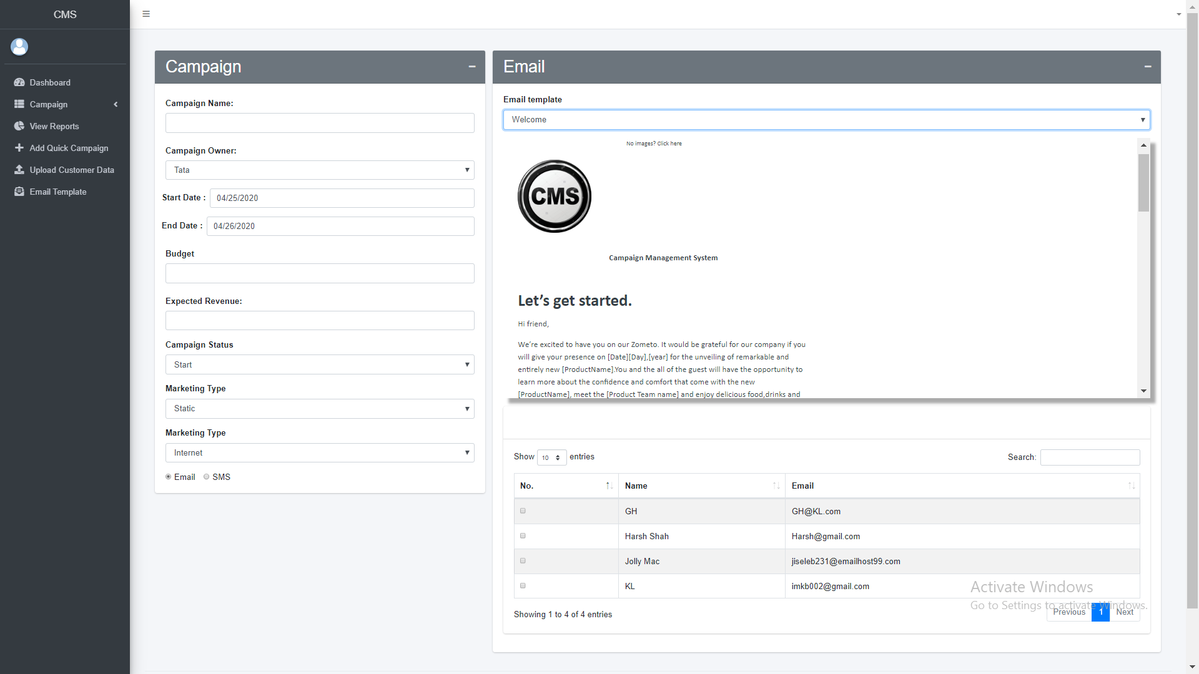

**Output- Manage City**

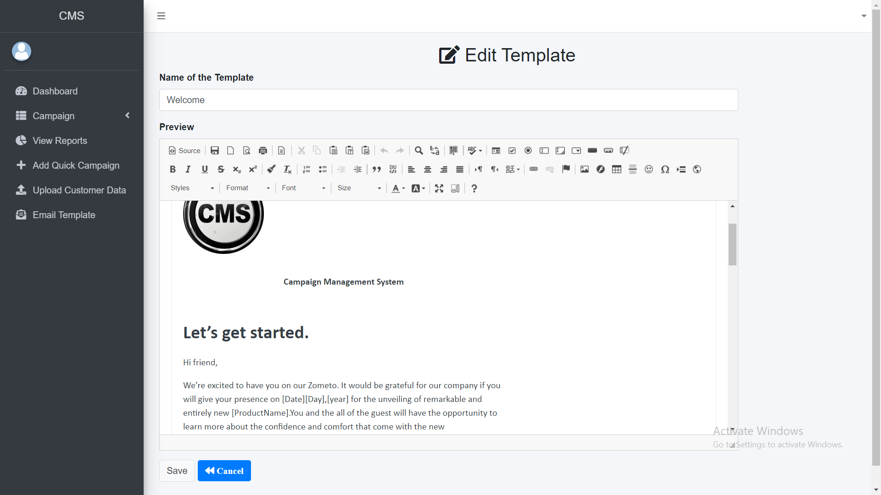

**CH-6 TESTING**

This chapter shows validation and testing of application.

|  |  |  |  |  |
| --- | --- | --- | --- | --- |
| Sr.no | TestCase | Expected Output | Actual Output | Test Case Result |
| 1 | For Login as admin provides correct admin credentials. | System should return admin dashboard | Admin dashboard | Pass |
| 2 | For Login as Organization User Provide correct credentials | System should return User dashboard | User Dashboard | Pass |

|  |  |  |  |  |
| --- | --- | --- | --- | --- |
| 3 | Add New User. | details should be stored in the database | User details are stored in database | Pass |
| 4 | For Adding New Campaign details are provided | Campaign list should be returned and stored in database | Campaign list with new added campaign and stored in database | Pass |
| 5 | Delete Campaign button is clicked | Campaign should be removed from the database and list should be returned. | Campaign list is returned and campaign is removed from database | Pass |
| 6 | Check customer Response for Campaign | System should return Customer response screen for campaign | Customer response screen for campaign | Pass |
| 7 | Upload  spreadsheet | Customer in spreadsheet should be stored in database and list should be returned | Customers are stored in database and list is returned | Pass |

|  |  |  |  |  |
| --- | --- | --- | --- | --- |
| 8 | Forgot password  Email address is provided | Random generated password should be mailed to given mail address | Random generated password is mailed | Pass |
| 9 | Welcome Mail | Welcome mail should sent to all customers on start date of campaign | Welcome mail is sent to all customers on start date | Pass |
| 10 | Send Feedback Mail | Feedback mail should be sent to all customers at end date of campaign | Feedback mail is sent to all customers on end date of campaign | Pass |

**CH-7 SUMMARY**

This chapter gives summary of the project which includes limitation & future scope of project.

**7.1 LIMITATION**

* Customer must have an internet connection to use this system.
* User must obtain a valid username and password to use this system. If user is not permitted, he/she will not be able to use the functionality of the system.
* It requires large database.
* The admin has to manually add the users
  1. **FUTURE SCOPE**
* Currently we are using only email to send campaigns but in future we will try to use sms and social media for sending campaigns.
* Currently we are using only buttons and radio buttons for response in future we will use textbox for getting feedback.
* Currently we are not able to predict campaign response in future we will predict what response will campaign get using previous campaigns responses
* In future we are planning to extend our system to be able to automate responses and send it to organization via email

within a test scenario and creating multiple such scenarios, creating a more generalized report of test results (pass or fail) using charts.

**BIBLIOGRAPHY**

* **C# Docs**

<https://docs.microsoft.com/en-us/dotnet/csharp/>

* **SQL Server Docs**

<https://docs.microsoft.com/en-us/sql/sql-server/?view=sql-server-ver15>

* **MVC Docs**

<https://dotnet.microsoft.com/apps/aspnet/mvc>

* **HTML Docs**

<https://devdocs.io/html/>

* <https://www.c-sharpcorner.com/>
* <https://www.infragistics.com/community/blogs/b/dhananjay_kumar/posts/how-to-implement-the-repository-pattern-in-asp-net-mvc-application>
* <https://stackoverflow.com/>
* <https://www.tutorialspoint.com/index.htm>